**Dedication**

We would like to dedicate this project to our respectable Father and Mother, my instructor, our Honorable teachers who are always dear and near to us and without whose patience, care, understanding, unsparing support, affection and most of all deepest love it would not have been possible to come up to this position.

**Acknowledgement**

At first, we praise to Almighty “Allah” who gave us opportunity, capability, energy, spirit and patience to complete this project work. It is our great pleasure to express our profound sense of gratitude to our Assistant Professor **Suman Saha**. Department of Computer Science and Engineering, for his constructive academic advice and guidance, constant encouragement and valuable suggestions, and all other supports throughout this project work and preparing this project report successfully. We are really benefited from his excellent supervision. We would like to thanks to all of our friends and those who helped, inspired and gave us mental support at different stages in different moment in our project. Again also thanks to the Almighty for helping us a lot in successfully ending this project work.

Mst. Yesmine Akter

Md. Foysal

Tanvir Parvej

**Abstract**

The Mobile Store Management System is software which can become the backbone for a billing and inventory system for small organizations. This software provides an uncomplicated system to run mobile stores. This application could be very useful to small organizations. This application is inspired from current pen and paper based store management systems. It will provide an easy and attractive interface so that the user can easily manage and utilize the application. Various other approaches were considered for this application. This application is designed in a way that it will only require a minimum amount of information from the user. The goal was to look for the minimum amount of information that will meet needed requirements.

**TABLE OF CONTENTS**

**CHAPTER -1: Introduction 1-3**

1.1 Introduction 1

1.2 Motivation 1

* 1. Project Objectives 2
  2. Key Benefits 2
  3. Contributions 2
  4. Conclusion 3

**CHAPTER 2: Background Knowledge 4-5**

2.1 Introduction 4

2.2 Literature Review 4

2.3 Problem Statement 5

2.4 Software Requirement 5

2.5 Hardware Requirement 5

**CHAPTER 3: Proposed System Analysis and Design 6-15**

3.1 Introduction 6

3.2 System Analysis 6

3.2.1 System Requirements 7

3.2.2 Analysis of exiting system 7

3.2.3 Analysis of proposed system 7

3.3 Method of information gathering 8

3.4 System design 8

3.5 System modeling 9

3.6 System flowchart 9

3.7 Functional Requirements 9

3.8 Technological Requirements 10

3.9 User Interface Requirements 10

3.10 Database specification 10

3.11 Database design 11

3.11.1 User account Table 11

3.11.2 Add supplier account table 11

3.11.3 Purchase Order Table 11

3.11.4 Payment Record Table 12

3.11.5 User login Table 12

3.11.6 Invoice Table 12

3.12 Entity Relationship Diagram (F-R Diagram) 13

3.12.1 General Overview 13

3.13 E-R Diagram Symbols and Notations 14

3.14 E-R Diagram 15

**CHAPTER 4: SYSTEM IMPLEMENTATION 16-18**

4.1 Introduction 16

4.2 Development Tools 16

4.2.1 Microsoft Visual Studio 16

4.2.2 MYSQL Community Server 17

4.2.3 NET Framework 17

4.3 System documentation 18

**CHAPTER 5: User Manual 19-28**

5.1 Login Panel 19

5.2 Update Password 19

5.3 Login Panel 20

5.4 Home page 20

5.5 User Account 21

5.6 Update user account successfully 21

5.7 User account successfully uploaded record show 22

5.8 Expenses 22

5.9 Expenses insert successfully 23

5.10 Sales Item Record 23

5.11 Bill Record 24

5.12 Search Bill Record 24

5.13 Invoice 25

5.14 Invoice All Item List 25

5.15 Invoice Print Preview 26

5.16 Payment Record 26

5.17 Payment Record Check 27

5.18 Add Supplier Info 27

5.19 Add Supplier Info. Successfully 28

5.20 Update Supplier Info 28

**CHAPTER 6: CONCLUTION 29-30**

6.1 Conclusion 29

6.2 Recommendation 29

6.3 Limitations 29

6.4 Future Goals 30

**CHAPTER 7 31-31**

**References 31**

**List of Figure**

**Figure No Title Page No**

Figure: 3.4 Waterfall model of system development life cycle 8

Figure 3.13 E-R Diagram Symbols and Notations 14

Figure 3.14 E-R Diagrams 15

Figure 5.1 Login Failed massage 19

Fieger 5.2 Update password 19

Figure 5.3 Login Panel 20

Figure 5.4 Home page 20

Figure 5.5 User Account 21

Figure 5.6 Update user account successfully massage 21

Figure 5.7 User account successfully uploaded record 22

Figure 5.8 Expenses 22

Figure 5.9 Expenses insert successfully 23

Figure 5.10 Sales Item Record 23

Figure 5.11 Bill Record 24

Figure 5.12 Search Bill Record 24

Figure 5.13 Invoice 25

Figure5.14 Invoice All Item List 25

Figure5.15 Invoice Print Preview 26

Figure 5.16 Payment Record 26

Figure 5.17 Payment Record Check 27

Figure 5.18 Add Supplier Info 27

Figure 5.19 Add Supplier Info. Successfully 28

Figure 5.20 Update Supplier Info 28

**List of Table**

**Table No Title Page No**

Table 3.1 User account Table 11

Table 3.2 Add supplier account table 11

Table 3.3 Purchase Order Table 11

Table 3.4 Payment Record Table 12

Table 3.5: User login Table 12

Table 3.6 Invoice table 12

**CHAPTER 1**

**INTRODUCTION**

* 1. **Introduction**

The Mobile Store Management System is developed for desktop systems to facilitate mobile shop owners’ management of customer details and inventory data, which will include mobile phones and accessories. It can be used efficiently for physically separated shops in different locations. This software will provide in a simple and easy to operate user interface, which can be managed by any user without having prior in-depth knowledge of the computer system. One can use this software to get a sales report. Administrators can pull data, from any location from the server. This software is a complete package for small organizations which will allow them to keep track of their sales and inventory, and provide a computerized billing system. There are various applications with more complex implementation and features available in the market, but they are generally very expensive. Therefore, creating an application with the basic requirement of low cost is essential for small organizations. This application will allow stores to manage customer details, keep inventory of all products and purchase information, in a very simple way, using a state-of the-art software application. It will automatically generate invoices and update inventory.

* 1. **Motivation:**

**­­­­**The concept of the Mobile Store Management system has been around for a long time, but it is still in the phase of discussion and design. Initially, all inventory and shop owners/employers using ledger- based systems managed billing reports manually. This requires a significant amount of time due to repeated access of the data. There is a high risk of lost or stolen data in that system. Storing old data is also one big factor. Stores have to spare one separate room to store this information. Paper- based documents might lose their information with time, and after some years, we cannot really read them at all. Therefore, the Mobile Store Management System is designed to reduce paper- based data storage system and provide digital touch to billing and inventory system.

* 1. **Project Objectives:**

**The system’s objectives are:**

All the information about sale, purchase will be maintaining properly in this system.

* All manual calculation of sale or all the money management will be performed by the computer automatically.
* This system will provide timely report information. It will produce report for sale, bill information.
* The computer can hold amount of data in its storage device.
* The operation and speed of the computer is very high. We can calculate result and print any report within seconds.
* Any difficulties we can solve easily. A database application can be stored in computer effectively.
  1. **Key Benefits:**
* All the information about sale, purchase will be maintaining properly in this system.
* All manual calculation of sale or all the money management will be performed by the computer automatically.
* This system will provide timely report information.
* It will produce report for sale, bill information.
* The computer can hold amount of data in its storage device.
* The operation and speed of the computer is very high.
* We can calculate result and print any report within seconds.
* Any difficulties we can solve easily.
* A database application can be stored in computer effectively.
* It is very user friendly and easy to handle. So the computerized system is more suitable than the manual system
  1. **Contributions**

1. Physical System under this project we discuss about how to develop a system.
2. Background structure of database.
3. User manual under this topic we show that how this projects works.
   1. **Conclusion**

Mobile Store Management System is application software designed to take advantage of today’s technology and reduce or avoid the burden of storing data on paper and in files. This facilitates moving purchase, sales, and customer information, as well as supplier and company data, from paper to digital media on a secured server. Sales and purchase bills can be generated as needed. Each store has an option to store their data on one remote central database server. This will also allow stores to access information from other partner stores. This would in turn lead to information sharing, so that all the stores are aware of each other’s current inventory. It will be useful when ordering new purchases to avoid overstocking.

**CHAPTER 2**

**Background Knowledge**

**2.1 Introduction**

Now a day a modern digital shop management system must have the ability to keep track of sales and inventory. It should also provide communication means to contact suppliers as needed. It should also allow the incorporating shop owner’s ideas to be implemented into the system. Implementing the idea of the previous section is practical for an inventory system, and requires combining many technologies into one common approach. The time taken by a customer care representative of any mobile store to enter information in the computer represents a base of the modern Mobile Store Management System. Merchants used to write down inventory and sales details. They had to search their paper records to estimate future needs and retrieve old sales information. They had to spend significant amount of time every day for such work.

**2.2 Literature Review**

During evolution from traditional management system, mechanical registers were also replaced by point-of-sale (POS) systems. POS systems helped to build capabilities and provide more important advantages. Historically, vendors of POS systems have focused their marketing efforts on large chain stores, but now they have turned their attention to small businesses because of their significant potential to grow and expand. Therefore, small organizations are also encouraged to use more powerful computer systems and software with a more attractive user interface that uses POS system instead of an old fashioned mechanical register system. For small organizations, such as mobile shops, product suppliers, and restaurant owners keeping transactions and inventory records is very hard and takes a lot of effort. POS system can be very beneficial for small organizations by providing smooth processes and functions. Such POS systems can be designed. As the local data cache is stored in a local drive and transfers to a remote sever, this POS system can provide significant benefits to the small organizations. This study proved that checkout processing time, which represents operational performance, was improved significantly both in the local and the remote server-client models, when an ADO data cache was embedded in the POS system. The more clients the proposed system served simultaneously, the greater savings it delivered, especially when large numbers of items were purchased in a sales transaction.

**2.3 Problem Statement**

The Current System is the manual one, hence is not speedy, accurate, efficient as well as time consuming. An essential part of the system analysis, which enables the developer to understand & the system correctly. It is undertaken to obtain details of the system. To understand the physical flow of the information through the current system. Collect various information through various fact finding techniques. Identify the procedural difficulties experienced by the user. Study the bottlenecks find out the redundant work being performed in the system. As mentioned above most of details are maintained manually. Due to this the data retrieved is time consuming. Due to human calculation errors occur. Even when the data is maintained on spreadsheet inconsistency occurs as an order might be missed or wrongly entered or twice. Data are stride an excel sheet which takes lot of time and data may be corrupted. As storage and exchange of data is achieved only by use of excel sheets which lack validation capabilities, there is always risk of invalid, inaccurate or incomplete data being fed in computer. Difficulty in managing multiple forms and lack of security.

**2.4 Software Requirement**

Operating system: Windows 10, Windows 7, Windows XP

Front-end- Tool: Visual studio 2019

Back-end Tool: MS SQL Server 2017

**2.5 Hardware Requirement**

1. A minimum hard disk space of 20 Gigabytes (GB)
2. RAM size of 1GB
3. Pentium 4 dual processor CPU
4. A VGA color monitor
5. Mouse
6. Keyboard

**CHAPTER 3**

**Proposed System Analysis and Design**

**3.1 Introduction**

System analysis is the study of sets of interacting entities, including computer system analysis. This field is closely related to requirements analysis or operations research. It is also “an explicit formal inquiry carried out to help someone identify a better course of action a make a better decision than he might otherwise have made. System Analysis is a methodology that involves the application of systematic approaches to collects fact about an existing system with the aim of improving or replacing it with more efficient system within the context of the available resources. In other words, it is a process of collecting and interpreting facts, identifying the problems, and decomposition of a system into its components.

**3.2 System Analysis**

System analysis is conducted for the purpose of studying a system or its parts in order to identify its objectives It is a problem solving technique that improves the system and ensures that all the components of the system work efficiently to accomplish their purpose. The process of studying a procedure or business in order to identify its goals and purposes and create systems and procedures that will achieve them in an efficient way". Another view sees system analysis as a problem-solving technique that breaks down a system into its component pieces for the purpose of the studying how well those component parts work and interact to accomplish their purpose.

The existing system is not totally automated. Though the system is not computerized to a particular extent,

The different processes involved are:

1. User friendly.
2. Less human error.
3. High security.
4. Easy data updating.
5. Easy record keeping.

**3.2.1 System Requirements**

A system requirements specification report basically describes and environment for software/application under development. It is completely describing the yield, cost, nature of the software/application.

**3.2.2 Analysis of exiting system**

The current system has several shortcomings that are as follows:

* The existing system was not very effective & was highly time consuming.
* The current system works manually.
* The existing system was somewhat paper-based (paper-work).
* The rate at which the work done is very slow due to non-utilization of computerized system.
* It does not provide better data facilities as well as data availability on fingertip.
* Inconsistency was the major problem in the existing system as there is no proper facility was provided to update the data.
* In case user wants to find out details of particular Mobiles whole database records are displayed.
* It is difficult to remember all data
* Consumes large volume of paper work
* Large storage space is required to keep to the files and register in proper coordination’s
* In the present system the report generation becomes very difficult.

**3.2.3 Analysis of proposed system**

The new system would easily overcome most of the short coming of the current system.

* Owner can see the fine report.
* Not much manual work is involved.
* Ensure data accuracy
* Security of data is done
* v)Save a lot of time and effort
* Optimize processing time.
* User friendly system.

**3.3 Method of information gathering**

Collection of fact is the act of getting and gathering information from various sources in order to be able to compose the project. Data used for designing of the system were gathered through several means. Therefore, the method used in the design and collections of information from various sources are as follows:

1. Collecting and analyzing existing materials on the project topic, written by different expert.
2. Studying the present system in detail and the organizational style.
3. Knowing and understanding the input and output processes of the existing system.
4. Knowing and understanding the input and output processes of the existing system.
5. Interviews: A qualitative form of interview was conducted in the blood bank to know the equipment needed.

**3.4 System design**

System design is the process of defining the architecture, components, modules, interfaces, and data for a system to satisfy specified requirements through system modeling. One could see it as the application of systems theory to produce development. The design of this system will be user friendly. It shall be designed in such a way that employees will be able to navigate easily through the information supplied on the system.

In other words, system design consists of design activities that produce system specifications satisfying the functional requirements that were developed in the system analysis process. System design specifies how the system will accomplish. System design is the structural implementation of the system analysis.

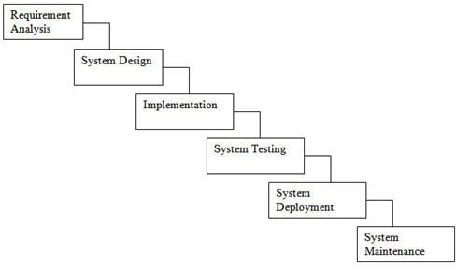

Fig: 3.4 Waterfall model of system development life cycle

The diagram above is a system development life cycle that illustrates how the design of the project is broken down into six different phases, which are Project Planning, Requirement Gathering, Project Implementation and Interface Design, Implementation and System Testing. Maintenance and System Upgrading.

**3.5 System modeling**

During the system requirements and design activity, systems may be modeled as a set of components and relationships between these components. These are normally illustrated graphically in a system architecture model that gives the reader an overview of the system organization. System modeling helps to give more detailed system specifications which are in form of graphical representations that can describe problem to be solved or the system that is to be developed. Because of the graphical representations used, models are often more understandable than detailed natural language description of the system requirements. Examples of such modeling tool are a System Flowchart.

**3.6 System flowchart**

System flowchart is a type of diagram that represents an algorithm or process, showing the steps as boxes of various kinds, and their order by connecting these with arrows. This diagrammatic representation can give a step-by-step solution to a given problem. Process operations are represented in these boxes, and arrows connecting them represent flow of control. Flowcharts are used in analyzing, designing, documenting or managing a process or program in various fields. Different symbols are used in the flowchart to represent input, output, decision, connectors and process.

**3.7 Functional Requirements**

The functional requirements of the application are as follows:

* The application shall have all required functionality which is necessary for mobile store inventory and billing system management.
* The application shall have ability to print bills and invoices.
* The application shall have functionality to be used by different stores from one location.
* The application shall have user name and password protected security system.

**3.8 Technological Requirements**

The technological requirements include the frontend programming tool and the backend database system. The application should be easy to use, and it should be easily managed by any person with little knowledge of computers. The database should be easy to install and configure. At the same time, it should be portable and independent so that we can use the database anywhere and install it on any laptop or PC. This application should be very easy to install on any machine. Finally, this application should not require higher configuration on any machine

**3.9 User Interface Requirements**

The application should be very simple and easy to use by any employee. Below are the basic requirements of general user interface:

* The application shall be easy to use.
* The application shall take few inputs from user.
* The understanding time of the application shall be very small

**Implementation:**

The system is implemented in AMD A6-5200 APU with Radeon(TM) processor with 4 GB RAM,64-bit computer. And it is implemented through testing on both Black and White testing. The language we use implement the system is Net Beans IDE, SDK, MYSQL database.

**3.10 Database specification**

A database is a single file which consists of structured data and records which are stored in minimum or no duplication of data. It is therefore a constructed, consistent and controlled pool of data. A good database must be common to all users and independent of the programs which use it to generate output. However, Microsoft Access was used as the database application tool for designing the database management system. The database management system is limited only to database administrator (Management). Whilst the system designer/developer/ programmer is responsible for maintaining and upgrading of the database and the whole software

**3.11 Database design**

This is a shared collection of data that are related or files that are to meet the immediate need of authorized users. These data may be in form of text, numeric, date or encoded images.

**3.11.1 User account Table**

|  |  |  |
| --- | --- | --- |
| **Column Name** | **Data Type** | **Field Length** |
| ID | Int |  |
| Name | Varchar | 20 |
| User Type | varchar | 20 |
| Email | nvarchar | 20 |
| Phone Number | nvarchar | 20 |

Table 3.1: User account Table

**3.11.2 Add supplier account table**

|  |  |  |
| --- | --- | --- |
| **Column Name** | **Data Type** | **Field Length** |
| ID | Int |  |
| NID Number | nvarchar | 20 |
| Name | varchar | 20 |
| Phone Number | nvarchar | 20 |
| Email | varchar | 20 |
| Home Address | nvarchar | 20 |
| Date | nvarchar | 20 |

Table 3.2: Add supplier account table

**3.11.3 Purchase Order Table**

|  |  |  |
| --- | --- | --- |
| **Column Name** | **Data Type** | **Field Length** |
| ID | int |  |
| Date | nvarchar | 20 |
| Categories | varchar | 20 |
| Item Name | varchar | 20 |
| Purchase Price | int |  |
| Company Name | varchar | 20 |
| Quantity | int |  |
| Total amount | int |  |
| Sale price | int |  |
| Bill number | int |  |
| Color | varchar | 20 |
| IMEI | varchar | 20 |
| Description | varchar | 20 |

Table 3.3: Purchase Order Table

**3.11.4 Payment Record Table**

|  |  |  |
| --- | --- | --- |
| **Column Name** | **Data Type** | **Field Length** |
| ID | int |  |
| Invoice Number | int |  |
| Date | datetime |  |
| Customer name | nchar | 20 |
| Total Amount | int |  |
| Customer Payment | int |  |
| Remaining payment | int |  |

Table 3.4: Payment Record Table

**3.11.5 User login Table**

|  |  |  |
| --- | --- | --- |
| **Column Name** | **Data Type** | **Field Length** |
| Username | Varchar | 20 |
| Password | Varchar | 20 |

Table 3.5: User login Table

**3.11.6 Invoice Table**

|  |  |  |
| --- | --- | --- |
| **Column Name** | **Data Type** | **Field Length** |
| Id number | int |  |
| Invoice number | int |  |
| Customer name | Varchar | 20 |
| Product name | Varchar | 20 |
| Price | int |  |
| Quantity | int |  |
| Total Amount | int |  |
| Date | datetime |  |

Table 3.6: Invoice table

**3.12 Entity Relationship Diagram (F-R Diagram)**

An entity relationship diagram (EDR) shows the relationships of entity sets stored in a database. An entity in this context is a component of data. In other words, E-R diagrams illustrate the logical structure database.

**3.12.1 General Overview**

An entity relationship diagram consists of several components. •RD has 3 simple components.

**Entities**

An entity is a thing. In business domain terms, it's a concept or glossary-level term. In relational database terms, it's the table.

**Relationships**

The real insight from this type of diagram comes when we see how entities relate to one another. or relationships. Relationships can be thought of as verbs that link two or more nouns. Relationships can be modeled numerically, using the multiplicity syntax from a class diagram, or using Crows Foot Notation.

**Attributes**

Within each entity, there can be more than one attribute. Attributes provide detailed information about the concept. In a relational database. attributes are represented by the fields where the information inside a record is held.

**3.13 E-R Diagram Symbols and Notations**

Entity Relationship Link

Multivalued Attributes Relation Type

Attributes

Figure 3.13: E-R Diagram Symbols and Notations

**3.14 E-R Diagram**

Admin

Customer  
Info

Supplier  
Info

Invoice

Manages

Adds

Purchase Order

Figure 3.14: E-R Diagram

**CHAPTER 4**

**SYSTEM IMPLEMENTATION**

**4.1 Introduction**

System implementation is a stage in system life cycle whereby a new system is developed, installed and made ready for use. It is this stage that all details and key point in the requirement specification are practicalised. System implementation therefore, is a very essential stage in which its success determines to a great extent the success of the new system. At this instance, after all is said and done the system is duly ready to be implemented (Pharmacy Management System). System design is concerned mainly with the coordination of activities, job procedures and equipment utilization in order to achieve organizational objectives. It addresses data input and output data, processing and interface.

**4.2 Development Tools**

**4.2.1 Microsoft Visual Studio**

Microsoft Visual Studio is an integrated development environment (IDE) from Microsoft. It is used to develop computer programs, as well as websites, web apps, web services and mobile apps. Visual Studio uses Microsoft software development platforms such as Windows API, Windows Forms, Windows Presentation Foundation, Windows Store and Microsoft Silver light. It can produce both native code and managed code. Visual Studio includes a code editor supporting intelligence (the code completion component) as well as code refactoring. The integrated debugger works both as a source-level debugger and a machine-level debugger. Other built-in tools include a code profiler, forms designer for building GUI applications, web designer, class designer, and database schema designer. It accepts plug-ins that enhance the functionality at almost every level—including adding support for source control systems (like Subversion and Get) and adding new toolsets like editors and visual 31 designers for domain-specific languages or toolsets for other aspects of the software development lifecycle (like the Team Foundation Server client: Team Explorer). Visual Studio supports 36 different programming languages and allows the code editor and debugger to support (to varying degrees) nearly any programming language, provided a language-specific service exists. Built-in languages include C, {6] C++, Visual Basic .NET, Cil, Fit, JavaScript, typescript, XML, XSLT, I ITML, and CSS. Support for other languages such as Python,181 Ruby, Nodc.js, and M among others is available via plug ins. Java (and .11#) were supported in the past.

**4.2.2 SQL Server**

Microsoft SQL Server is available in several versions and editions. Available editions run from a basic Express edition to a fully featured Enterprise edition. The Express edition is free but still has an abundance of features that allow you to get started with full-fledged database development. The Enterprise edition includes many sophisticated database management features, plus complex business intelligence components. SQL Server is a more robust database management system. SQL Server was designed to have many hundreds, or even thousands of users accessing it at any point in time. Microsoft Access, on the other hand, doesn't handle this type of load very well. SQL Server is a database application to look after the backend of a system (storing the data, controlling transactions, etc.). There are many options available, ranging from SQL Server Express Edition (formally MSDE) which supports 5-10 simultaneous users, to SQL Server Enterprise Edition. Having a centralized place to store data is a great benefit to SQL Server users. Centralization is the primary SQL Server benefit that means that everyone is using the same data source. As a result, there is no need to merge information together in order to receive an accurate version of a record. With centralized data, every time that you retrieve a record, you will be confident that you have the latest information.

**4.2.3 NET Framework**

NET Framework (pronounced dot net) is a software framework developed by Microsoft that runs primarily on Microsoft Windows. It includes a large class library named Framework Class Library (FCL) and provides language interoperability (each language can use code written in other languages) across several programming languages. Programs written for .NET Framework execute in a software environment (in contrast to a hardware environment) named Common Language Runtime (CLR), an application virtual machine that provides services such as security. memory management, and exception handling. (As such, computer code written using NET Framework is called "managed code".) FCL and CLR together constitute .NET Framework. FCl. provides user interface, data access, database connectivity, cryptography, web application development, numeric algorithms. and network communications. 32 Programmers produce software by combining their source code with NET Framework and other libraries. The framework is intended to be used by newest applications created for the Windows platform. Microsoft also produces an integrated development environment largely for .NET software called Visual Studio.NET Framework began as proprietary software, although the firm worked to standardize the software stack almost immediately, even before its first release. [8] Despite the standardization efforts, developers, mainly those in the free and open-source software communities, expressed their unease with the selected terms and the prospects of any free and open-source implementation, especially regarding software patents. Since then, Microsoft has changed NET development to more closely follow a contemporary model of a community-developed software project, including issuing an update to its patent promising to address the concerns. [8] NET Framework led to a family of NET platforms targeting mobile computing. embedded devices, alternative operating systems, and web browser plug-ins. A reduced version of the framework, NET Compact Framework, is available on Windows CE platforms, including Windows Mobile devices such as smart phones. NET Micro Framework is targeted at very resource-constrained embedded devices. Silver light was available as a web browser plug-in. Mono is available for many operating systems and is customized into popular smartphone operating systems (Android and iOS) and game engines. NET Core targets the Universal Windows Platform (UWP). and cross-platform and cloud computing workloads.

**4.3 System documentation**

System documentation is a crucial aspect of implementation process. It describes the working of components and serves as a method of communication between application developers and users. It also helps future analysis of application either by the same or different system analysts and developers. 'co setup the system, there must be visual basic 6.0software installed on the computer before it can work.

**CHAPTER 5**

**User Manual**

**5.1 Login Panel**

The Mobile Store Management System is a secure application, and a user needs to enter the proper combination of Username and Password to access application. This is the login page. If Username & password don’t match, this message will be showed by this massage.

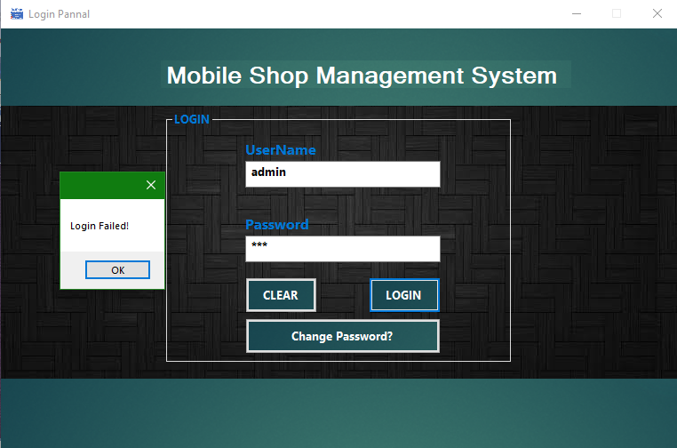

Figure 5.1: Login Failed massage

**5.2 Update Password**

This is also a very necessary function of this application. Using this form user can change his password. Also can update password panel if there is need.

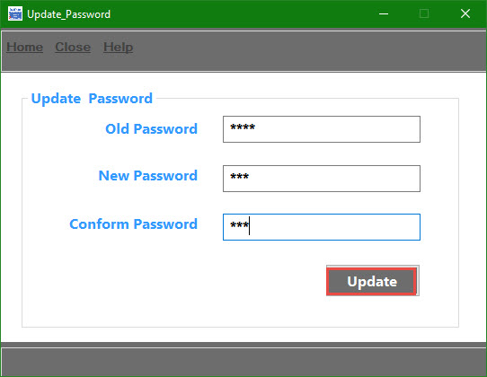

Fieger 5.2: Update password

**5.3 Login Panel**

This application has one Username and one Password, but we can implement multiple users with user- wise limitation and access control. There is also clear and change password option. This is the Login Panel page where we can login as user and also have admin login option.

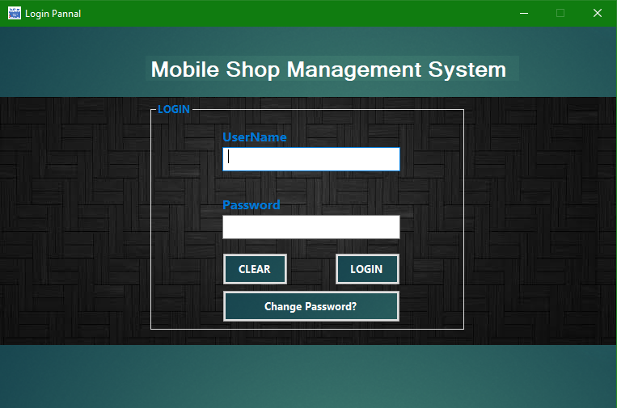

Figure 5.3: Login Panel

**5.4 Home page**

We have discussed earlier that this application is developed in Visual Basic. Visual Basic is commonly used for standalone applications. We can create a package, which can be installed on any system easily. Visual Basic provides a simple and attractive user interface to the user. Any user can easily manage the application using this interface. This is the home page (Shop Details) page.

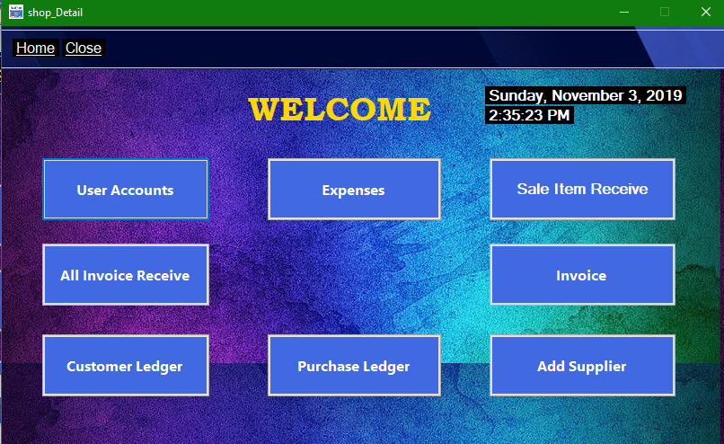

Figure 5.4: Home page

**5.5 User Account**

These are the different pages, which are known as forms in Visual Basic. These forms will be majorly used by the user during daily work using this application. There are several forms available based on requirement of application. In this from shopkeepers add their information for store their record in the system.

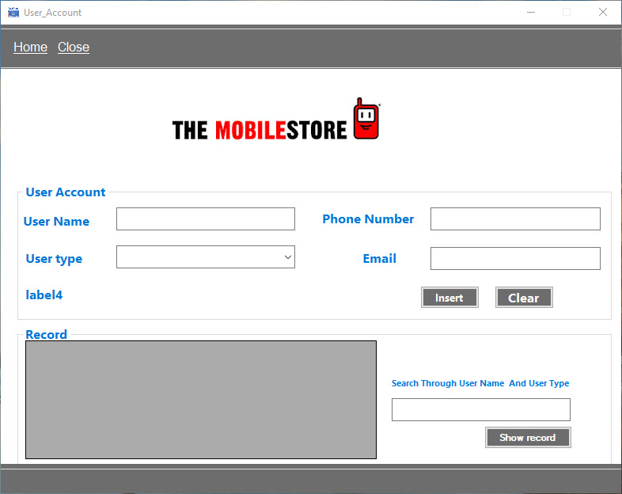

Figure 5.5: User Account

**5.6 Update user account successfully**

After add information in this from shown the information’s are successfully store in the record in user accounts and also show a successfully upload message.

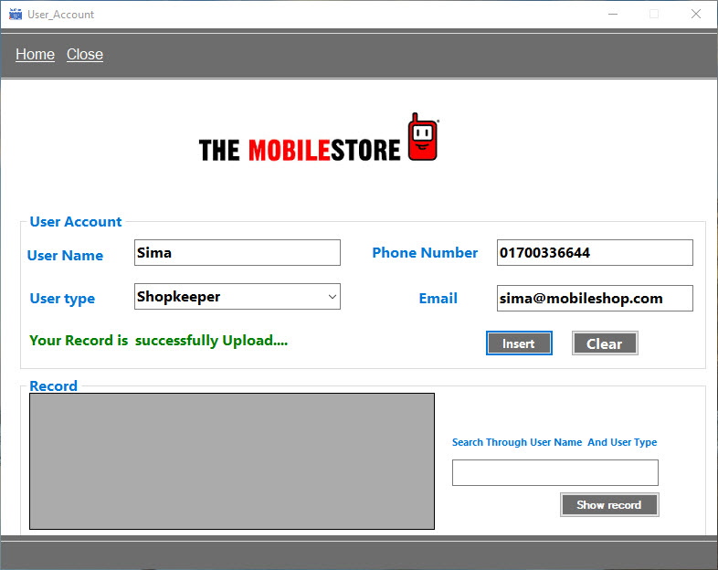

Figure 5.6: Update user account successfully massage

**5.7 User account successfully uploaded record show**

In this from we can show the successfully stored information record and also search for the information about employees.

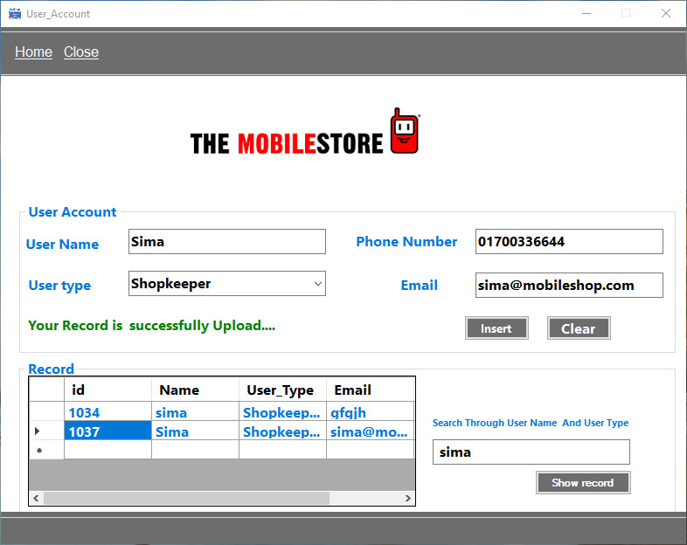

Figure 5.7: User account successfully uploaded record show

**5.8 Expenses**

In this from there is information about the expenses in the mobile shop. It also shown the date, expenses tittle, amount.

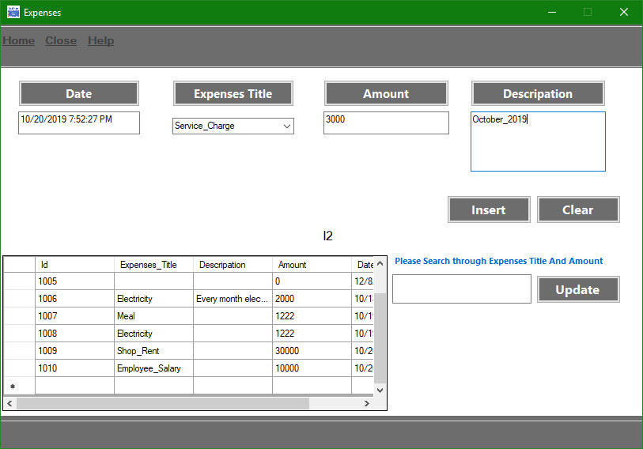

Figure 5.8: Expenses

**5.9 Expenses insert successfully**

This form shows the successfully insert record of expenses in the mobile shop.

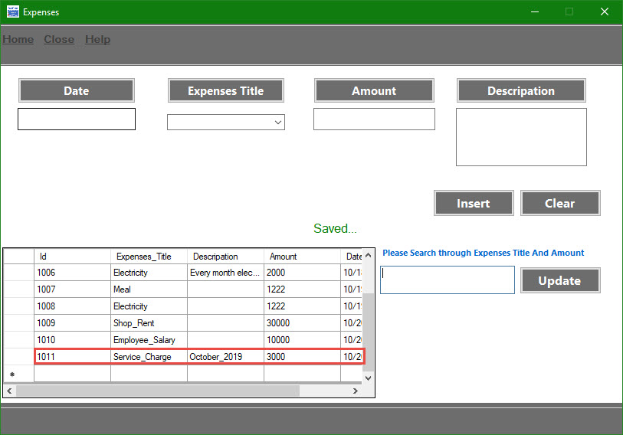

Figure 5.9: Expenses insert successfully

**5.10 Sales Item Record**

In the mobile store which items are in shop and products details are shown in this like item name, quantity, price, company name etc.

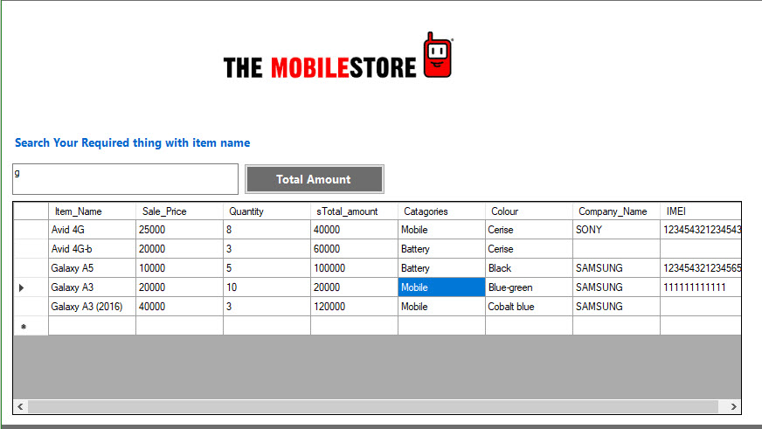

Figure 5.10: Sales Item Record

**5.11 Bill Record**

In this from shown the information about bills of months. Also can clear, search or check record of the products.

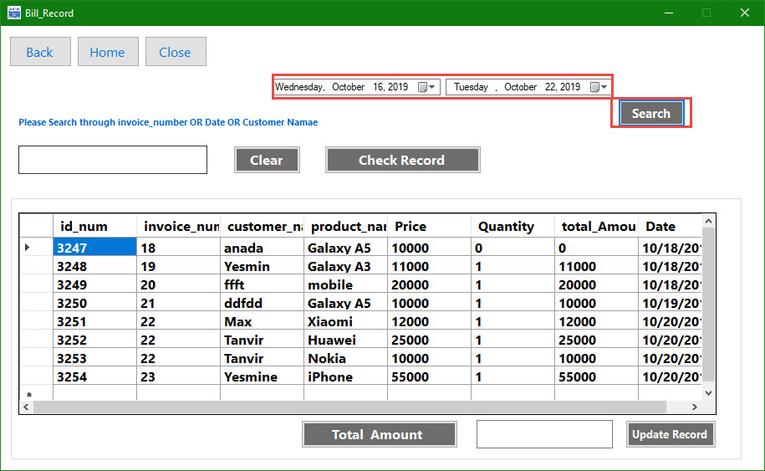

Figure 5.11: Bill Record

**5.12 Search Bill Record**

In this from we can search bill record of customers and check records.

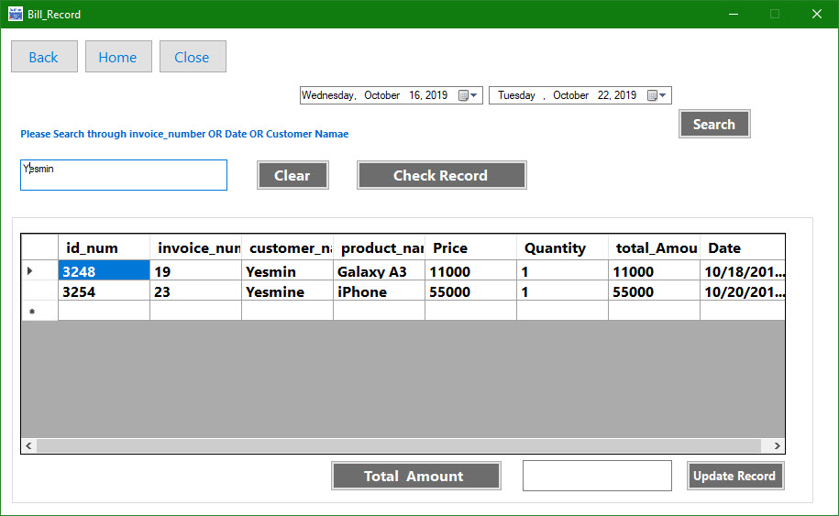

Figure 5.12: Search Bill Record

**5.13 Invoice**

By using this from Admin can check all the invoice information.

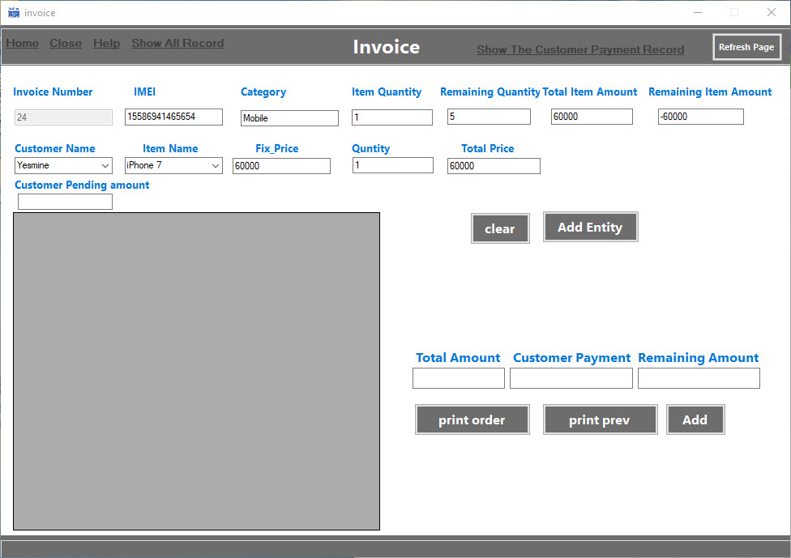

Figure 5.13: Invoice

**5.14 Invoice All Item List**

In this from also can show the all sells products information list.

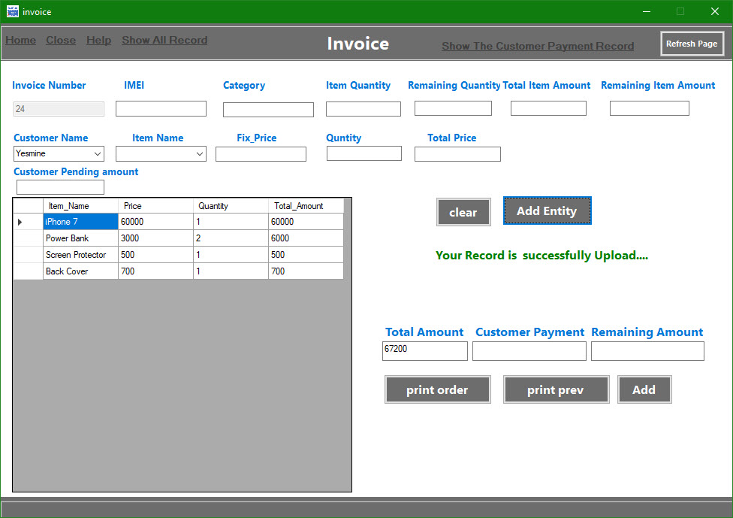

Figure 5.14 Invoice All Item List

**5.15 Invoice Print Preview**

By this from the item which sold to customer print the bill.

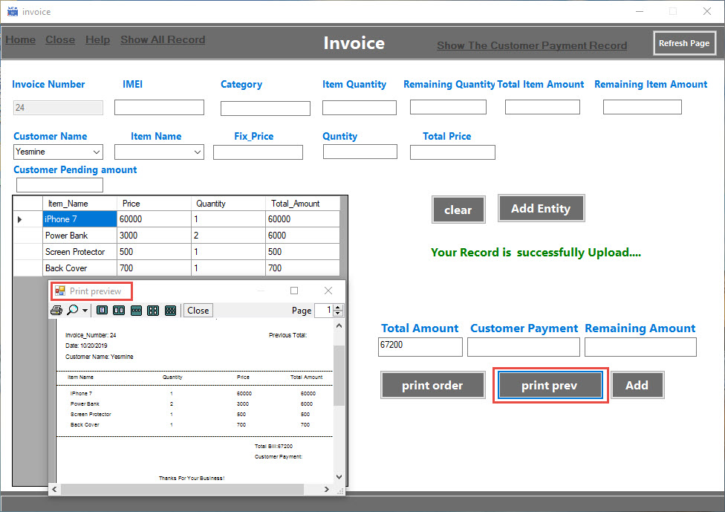

Figure 5.15: Invoice Print Preview

**5.16 Payment Record**

In this features shown the due payment record of customers.

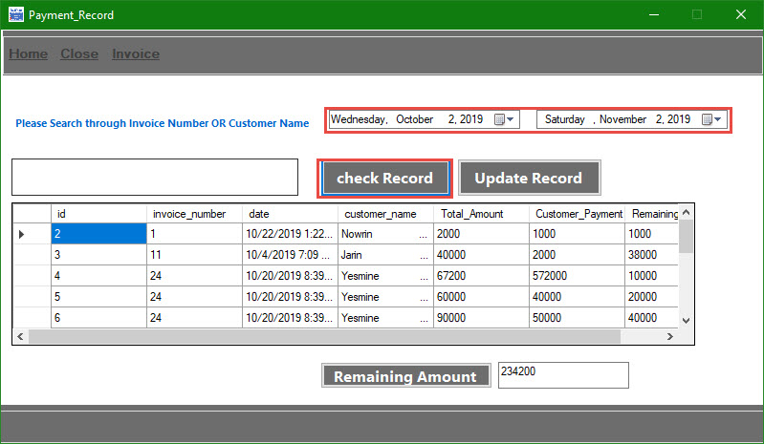

Figure 5.16 Payment Record

**5.17 Payment Record Check**

In this from it can recheck the payment.

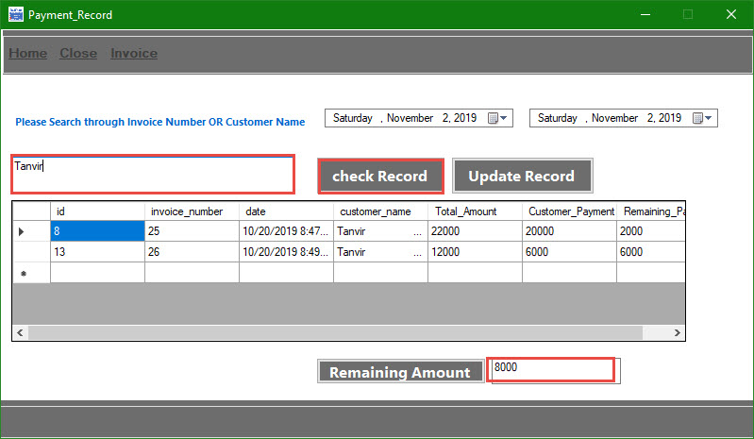

Figure 5.17 Payment Record Check

**5.18 Add Supplier Info**

The supplier Information form has information related to any supplier we have on record. This is basic information about the supplier in case we need to contact that supplier in the future for further purchases or inquiry about past purchases.

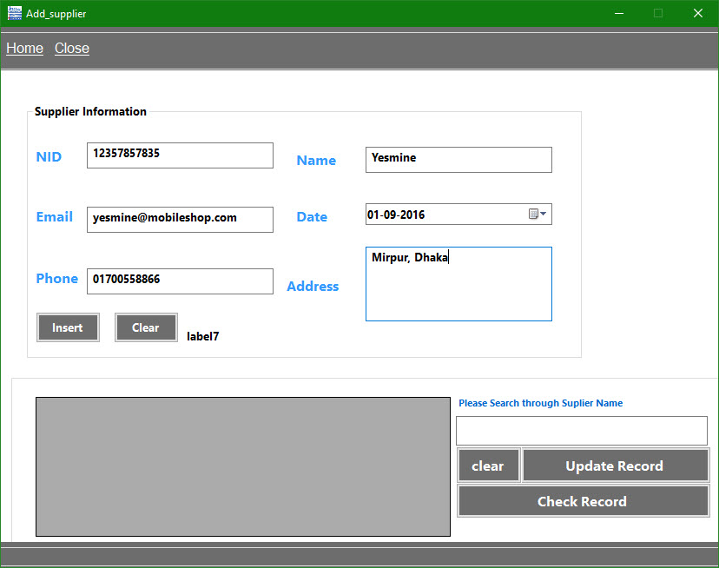

Figure 5.18 Add Supplier Info

**5.19 Add Supplier Info. Successfully**

This is the form for shown successfully add supplier’s information.

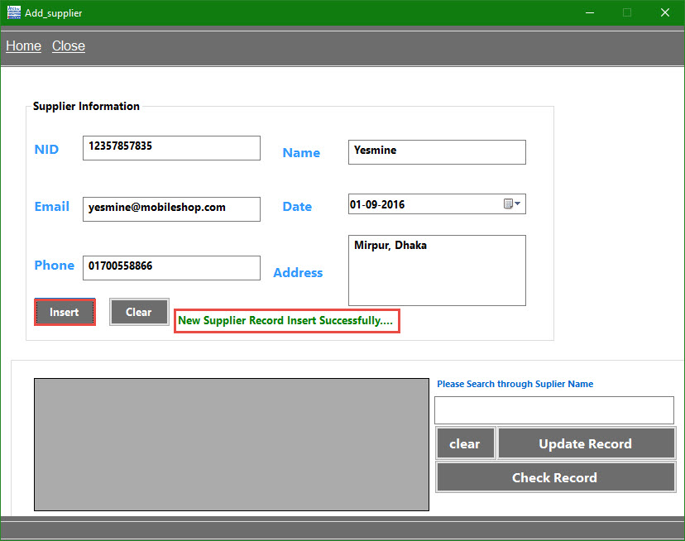

Figure 5.19 Add Supplier Info. Successfully

**5.20 Update Supplier Info**

This is also a very necessary function of this application. If any information for supplier, sales or purchase is changed after its original entry, we can update that information very easily using this function. We just need to edit existing data and click on Update button.

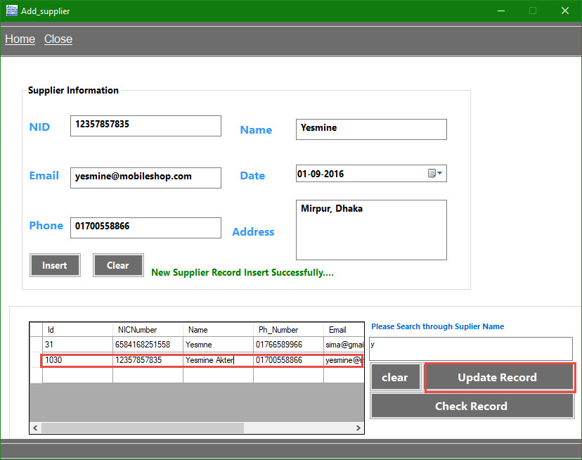

Figure 5.20 Update Supplier_ Info

**CHAPTER 6**

**CONCLUTION**

* 1. **Conclusion**

An attempt is made in all its earnest towards the successful completion of the project. This system was verified with valid as well as with invalid data. This system is user friendly since it has been developed in visual studio a successful GUI environment. Since the connection can be extended to any database. The control will be more powerful. Connecting it to any type of database extends the development control. Any suggestions for future development of the system are welcome Upgrading the system if may can be done without affecting the proper functioning of system.

* 1. **Recommendation**

Designing this application (Mobile Shop Management System) is not an easy task. It all started from the requirement gathering and passes through so many other stages before completion. Based on the benefits of this system and tremendous value it will add to user satisfaction, the below recommendation will be considered.

It is recommended that the new system should be used with the necessary specifications of the system requirements and provision for an uninterrupted power supply should be made available. There should also be basic computer knowledge for the users of the software.

* 1. **Limitations**

There are some drawbacks and limitations in this software as it is a beta release and under further development process.

1. Need to install first on computer before using
2. Platform is not independent: it can't run on all devices
3. Some minor bug exists
4. Limited features need to exploit
   1. **Future Goals**

We can add multiple usernames and passwords with user- wise separate access and authorities. We can implement search function using different information also. It is also possible to integrate an employee’s time card and a payroll management system in this application. There is another idea to implement SIM card management system. Using bar code scanner and smart card reader, we can minimize manual data entry, which will potentially decrease the amount of time to enter data. But at the same time it will increase the cost of this application.

**CHAPTER 7**

**References**

1. SCRIBD [Online]

Available at:

<https://www.scribd.com/doc/97508346/Mobile-Store-Management-System>

1. ACADEMIA [Online]

Available at:

<https://www.academia.edu/28215202/MOBILE_SHOP_MANAGEMENT_SYSTEM_Team_Class_CMU-IS_432_AIS_Lecture_Project_Management_Lecturer>

1. SlideShare [Online]

Available at:

<https://www.slideshare.net/NiteshKumar171/127801976-mobileshopmanagementsystemdocumentation>

1. ResearchGate [Online]

Available at:

<https://www.researchgate.net/publication/296567586_Job_shop_management_system_based_on_cost_control>

1. Wikipedia. [Online]

Available at:

<https://en.wikipedia.org/wiki/Mobile_content_management_system>